**Credential Suspend**

1.Suspending credential for a predefined period if its lost/stolen.

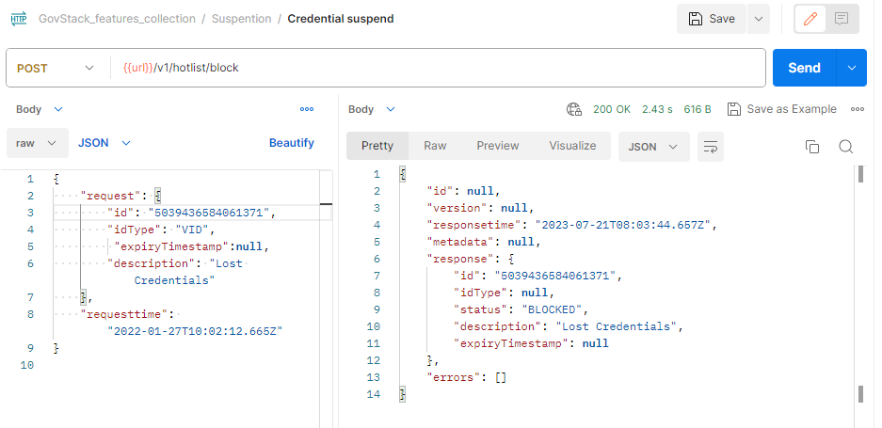

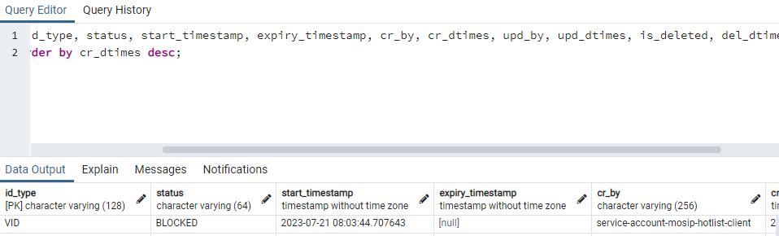2.Remarks/Reason in hotlist.hotlist table.

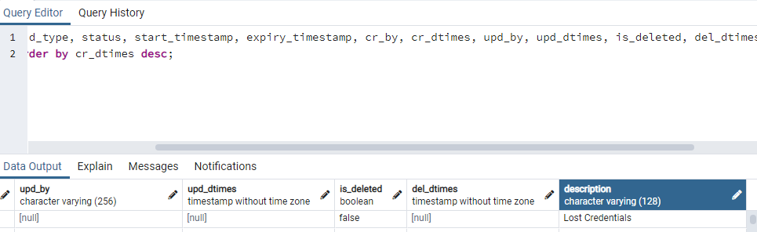

Notification

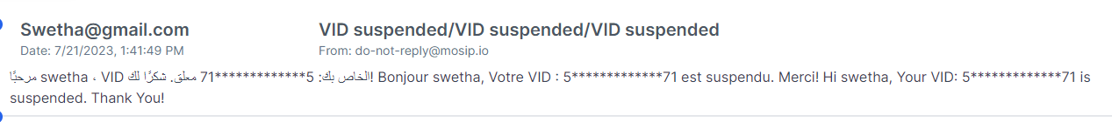

**Integration flow with the Suspended credentials**

1. OTP Authentication with suspended credential

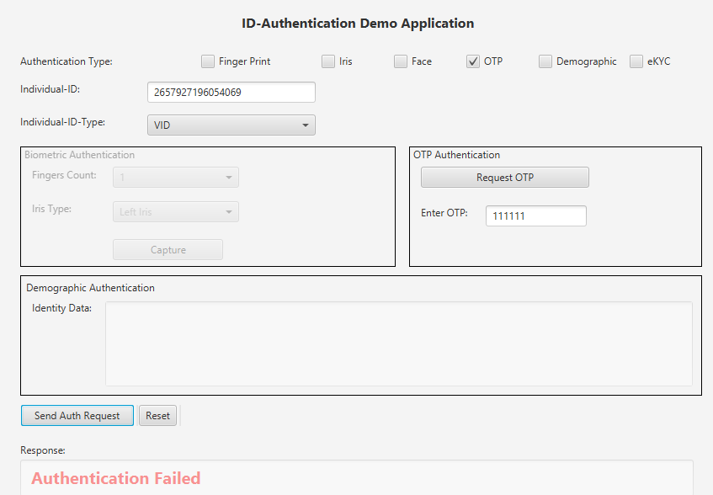

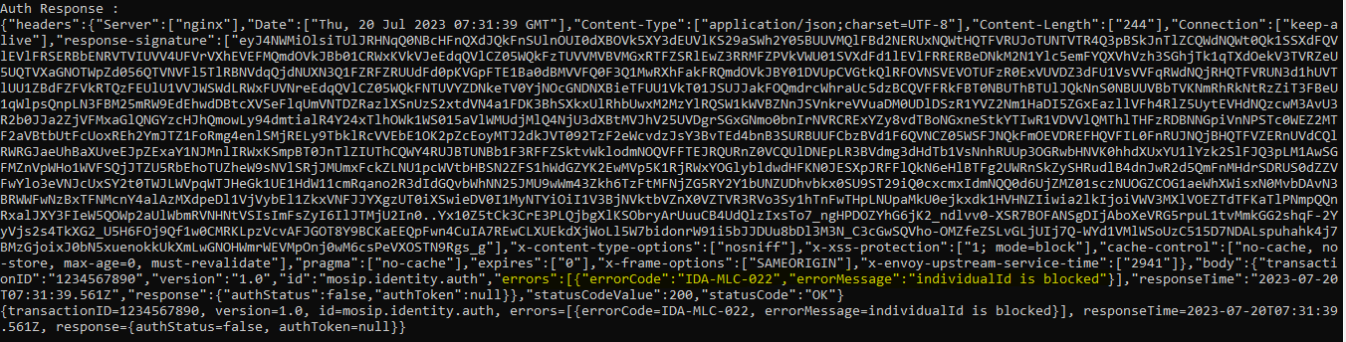Notification not received for credential suspension.

1. Demographic Authentication with suspended credential.

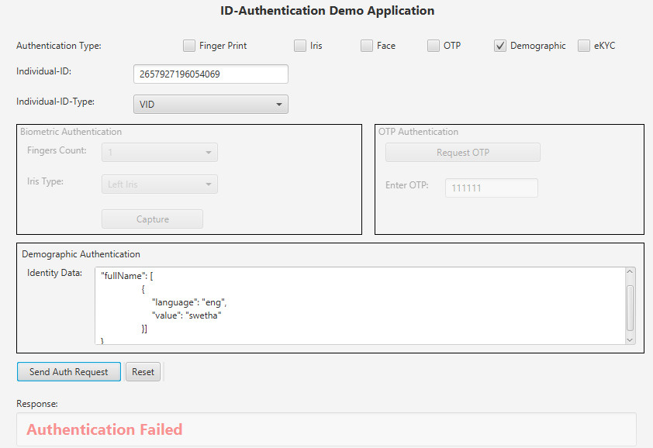

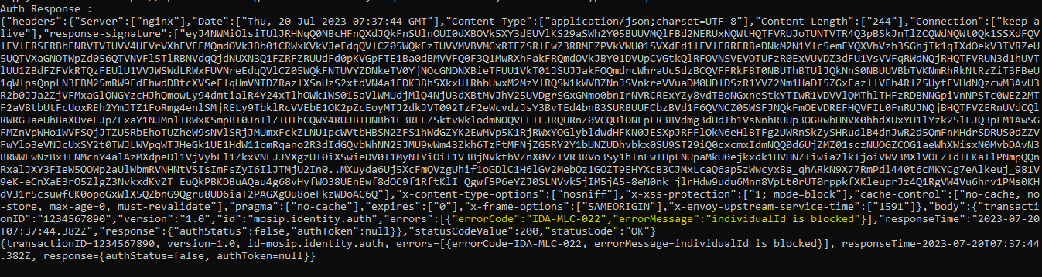Notification not received for credential suspension.

3.Bio Authentication for Face with suspended credential.

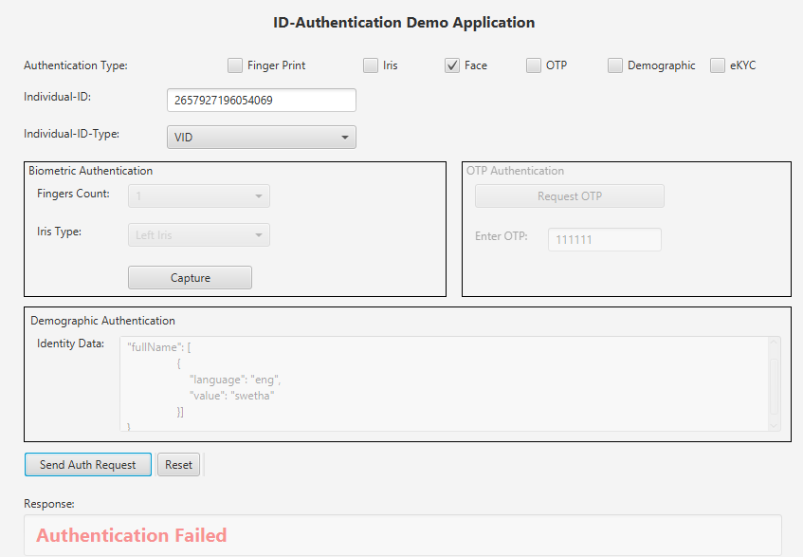

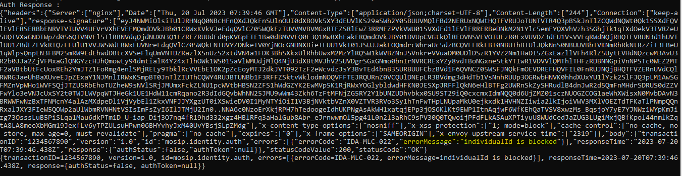Notification not received for credential suspension.

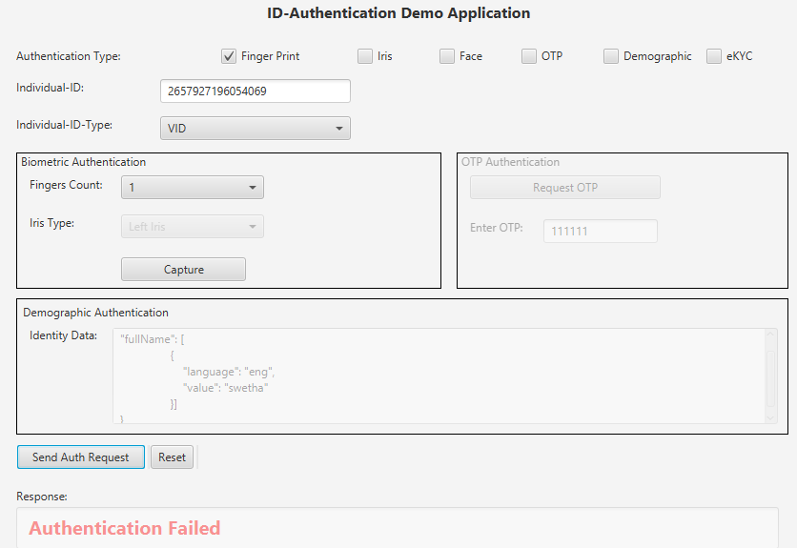4. Bio Authentication for Finger with suspended credential.

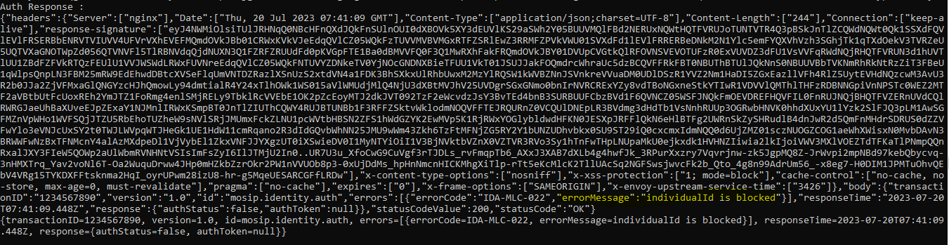

5.Bio Authentication for iris with suspended credential.

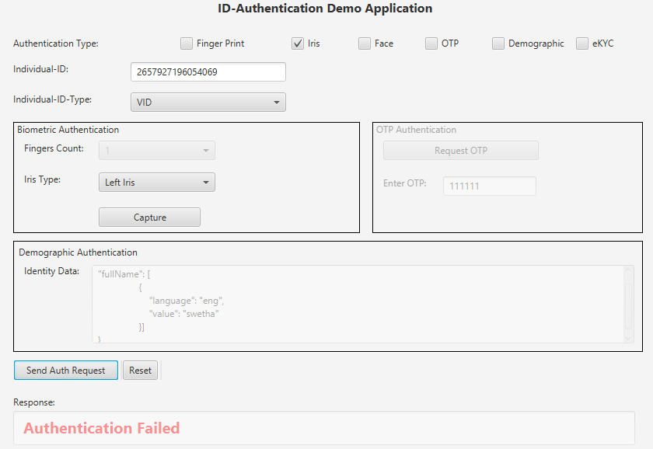

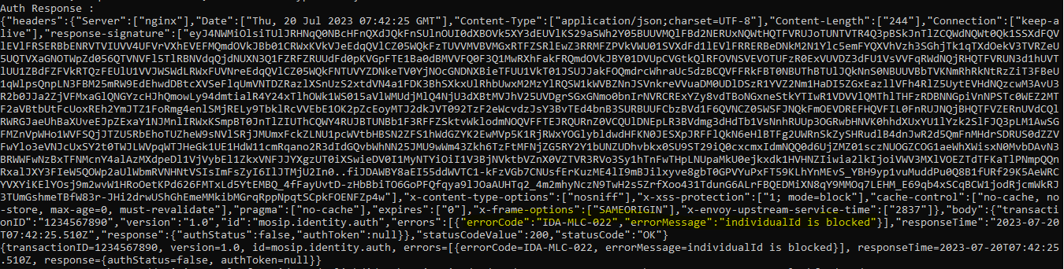Notification not received for credential suspension.

6. Ekyc authentication with suspended credential.

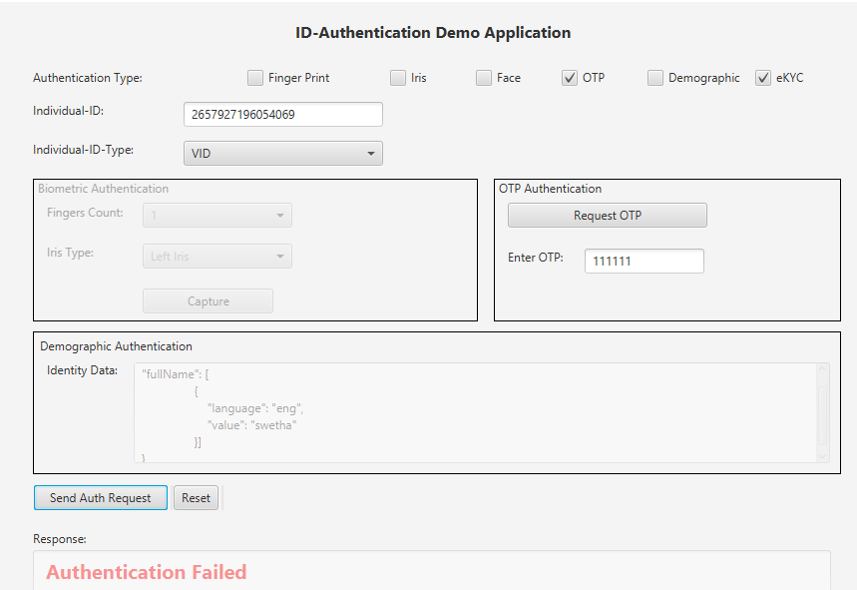

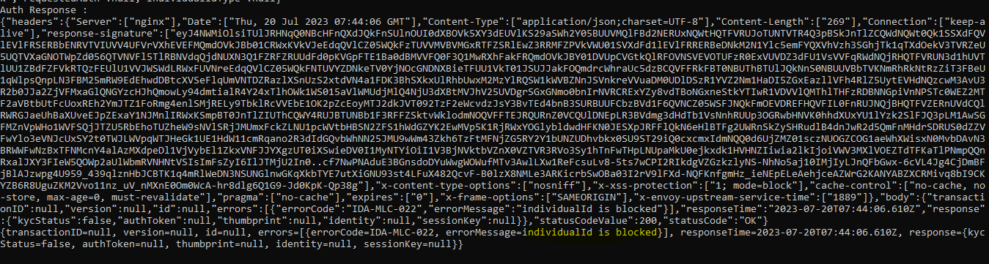Notification not received for credential suspension.

7. Retrieve suspended credential details

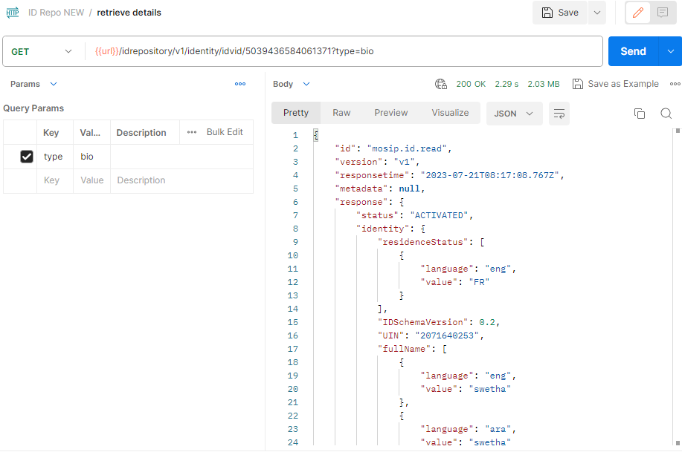

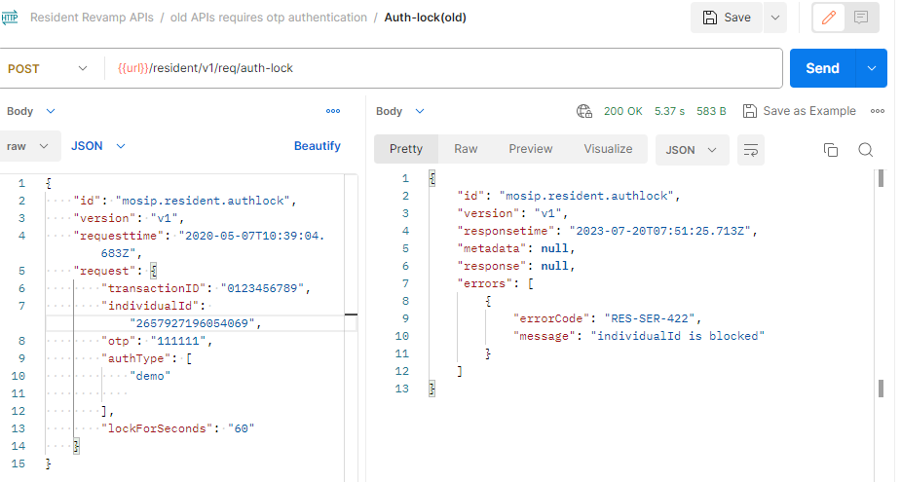8. Auth lock with suspended Credential.

9.Download card allowed with suspended credential.

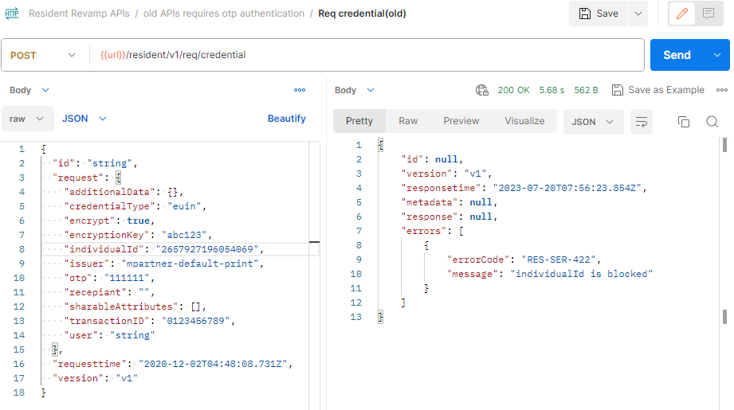

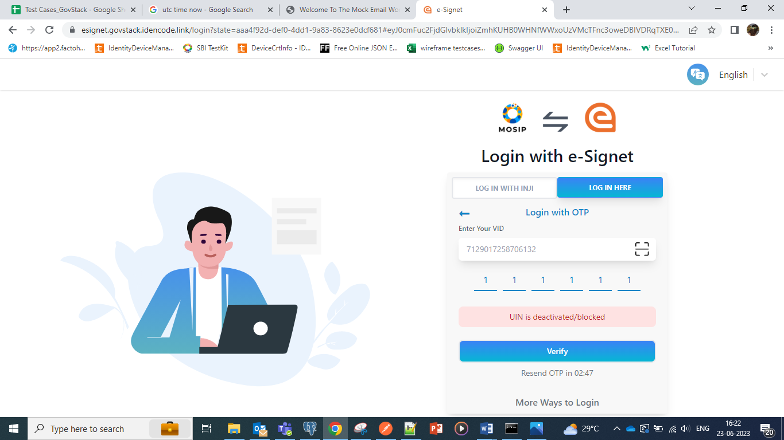10.Login to resident service portal with suspended Credential.

11. Revoke Credential with Suspended credential.

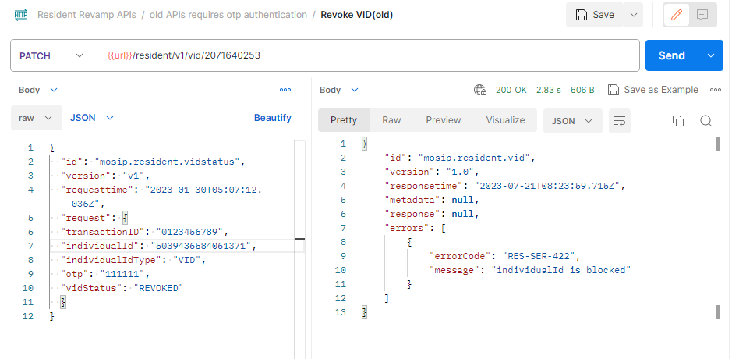

12. Credential share with suspended Credential.



13. Login to Health service portal with suspended Credential

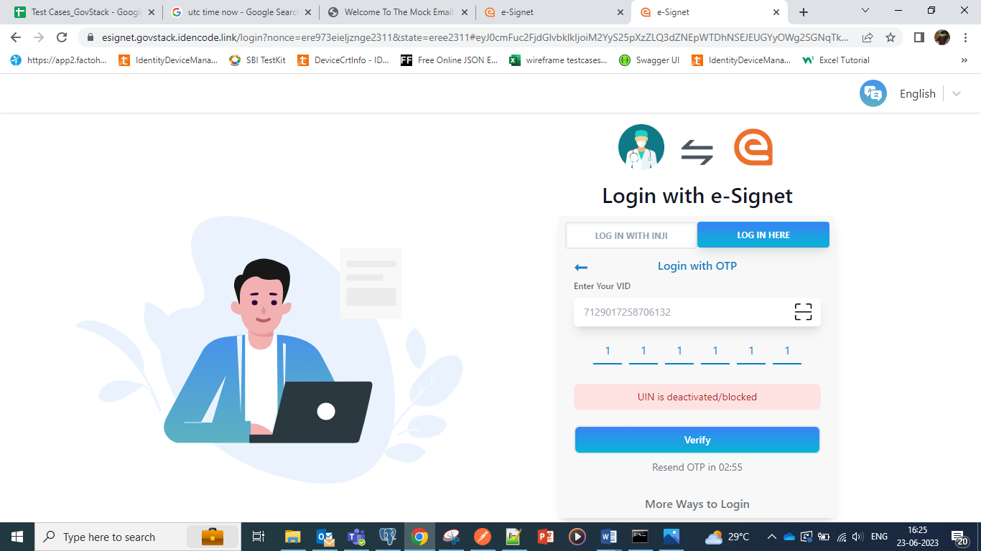

**Credential Unsuspension:**

1.Unsuspend credential for a predefined period if its lost/stolen.

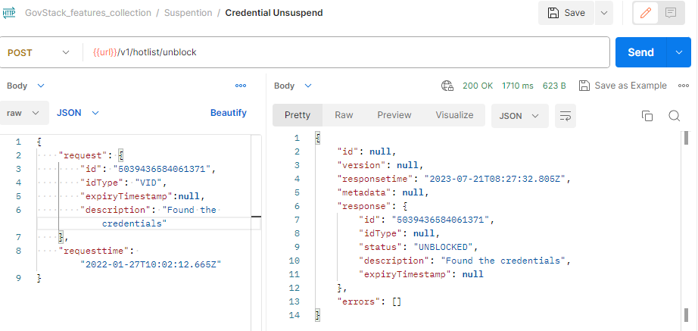

2.Remarks/Reason displaying in hotlist. hotlist table.

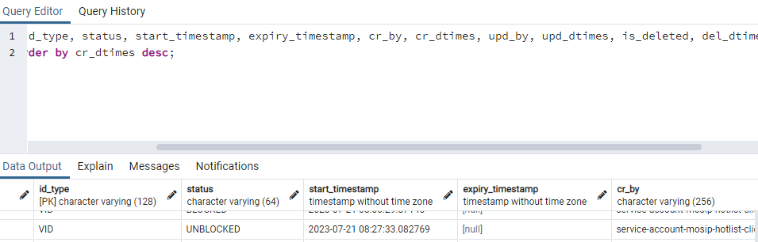

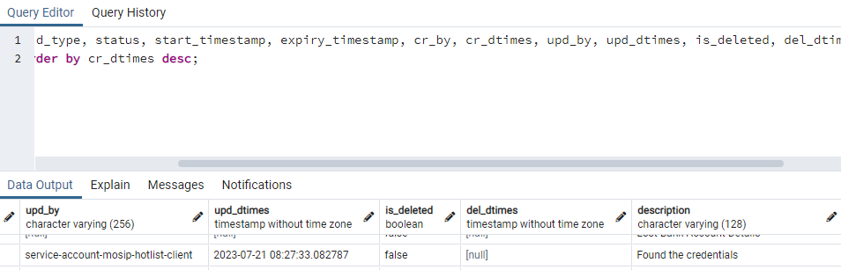

Notification

**Integration flow with unsuspended Credential**

1. OTP authentication with unsuspended credential

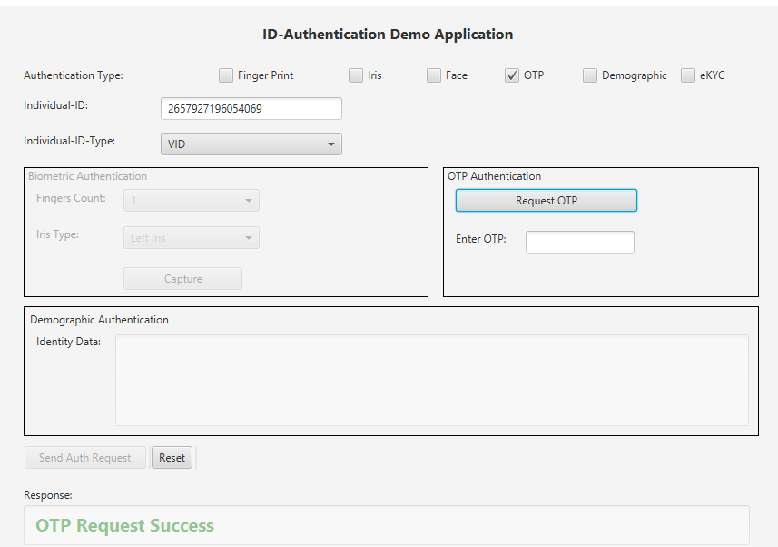

Notification

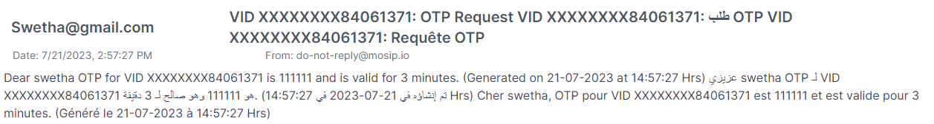

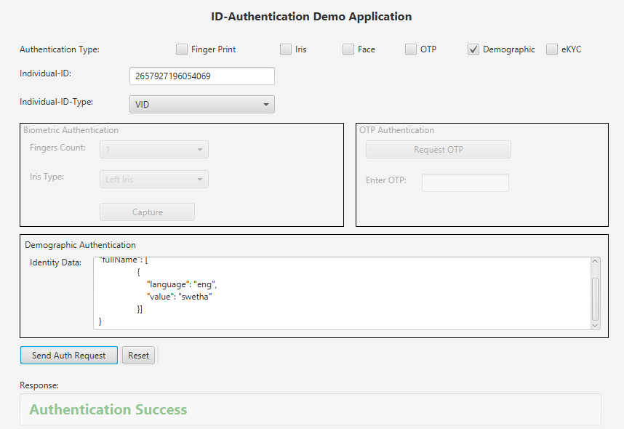2. Demo Authentication with unsuspended credential

Notification

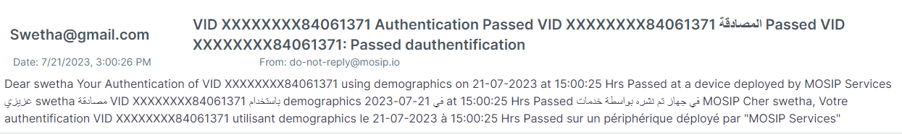

1. Bio Authentication for Face with unsuspended credential

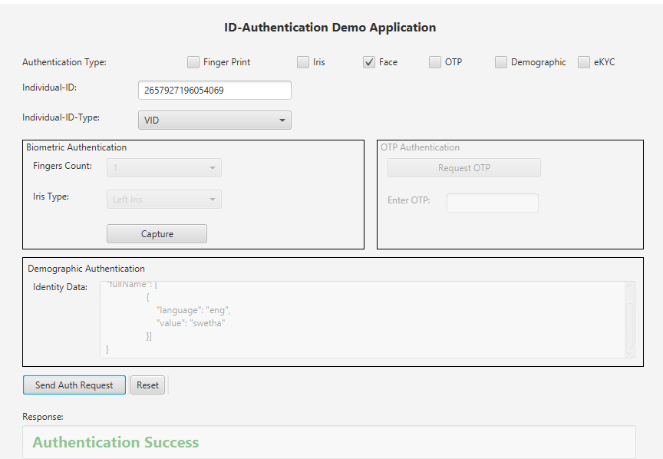

Notification

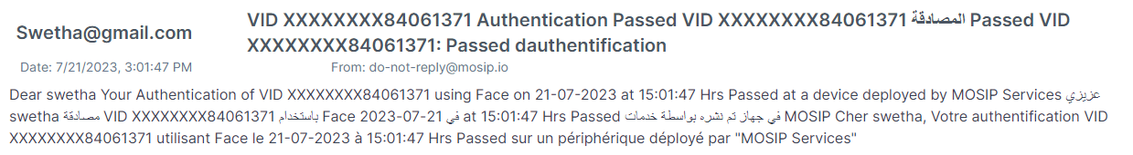

4. Bio Authentication for Finger with unsuspended credential

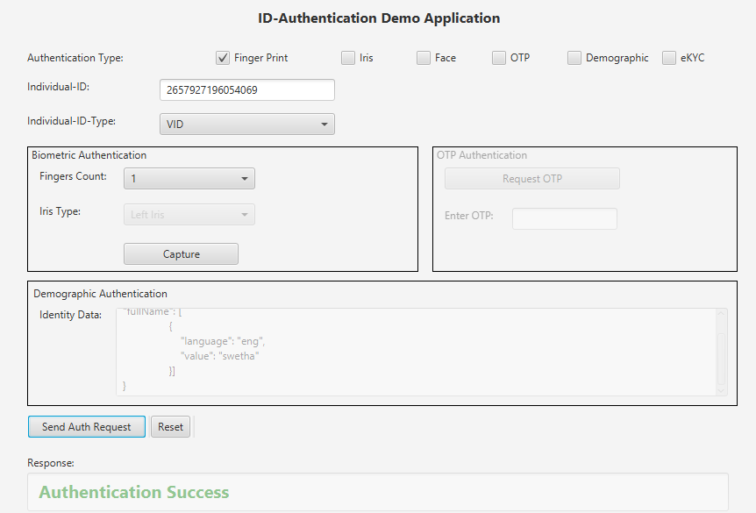

Notification

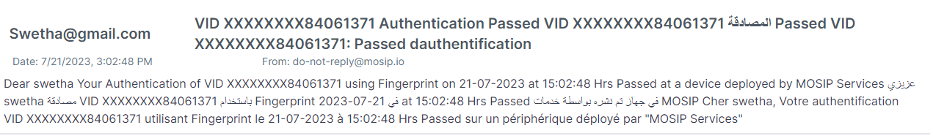

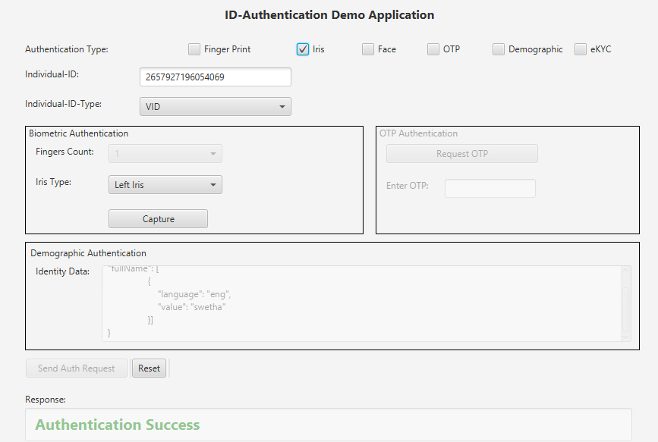5. Bio Authentication for iris with unsuspended credential

Notification



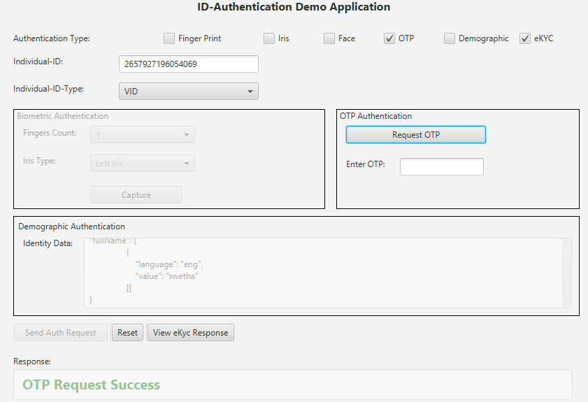6. EKYC authentication with unsuspended credential

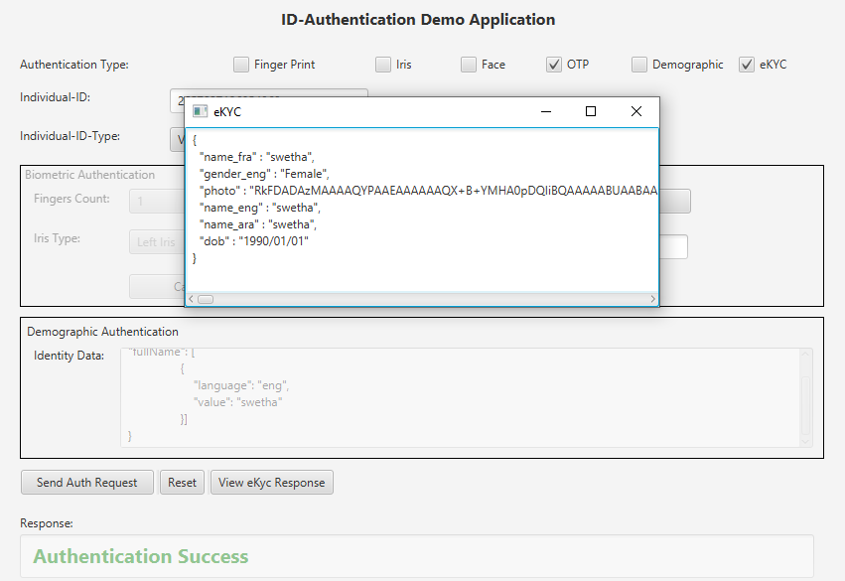

Notification

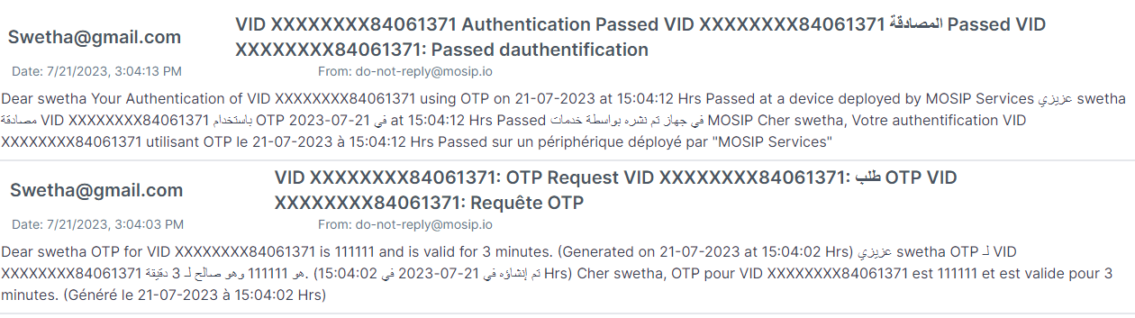

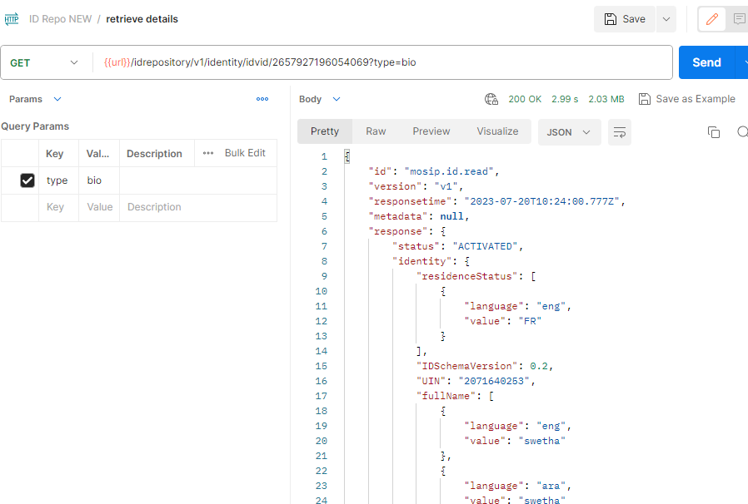7. Retrieve details with unsuspended credential

8. Auth lock for unsuspended Credential.

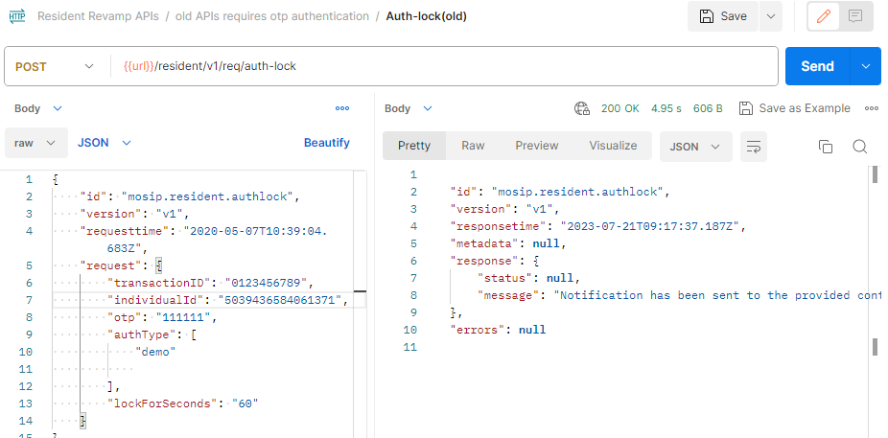

Notification

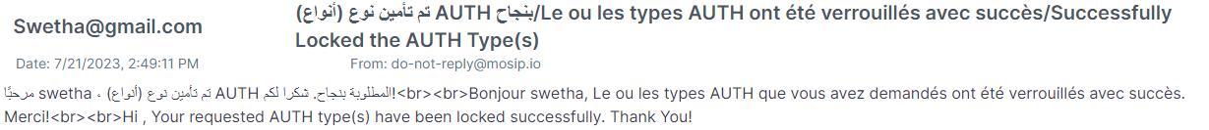

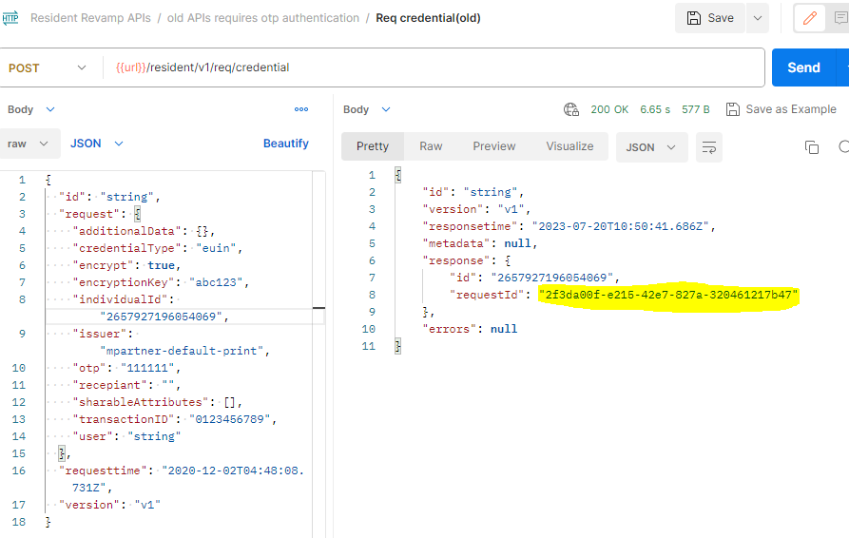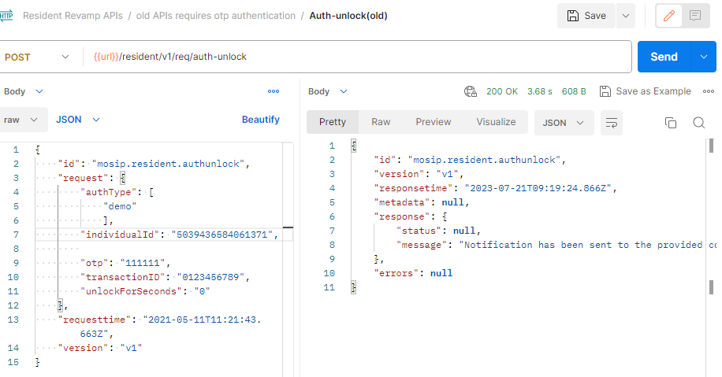9. Auth unlock for unsuspended Credential

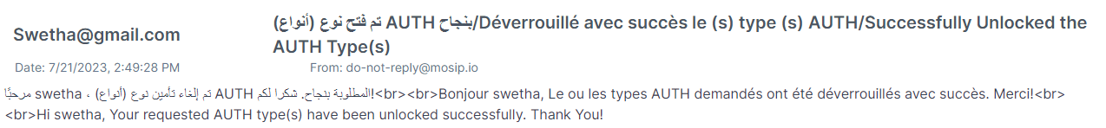Notification

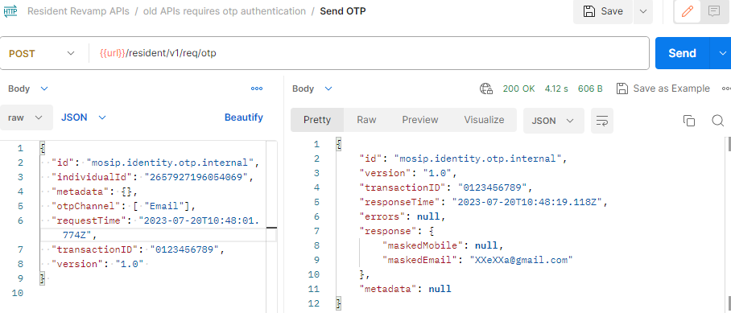10. Download card with unsuspended credential

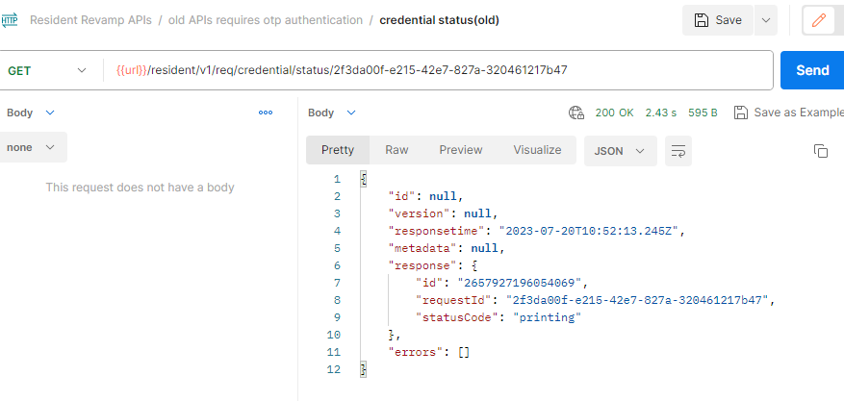

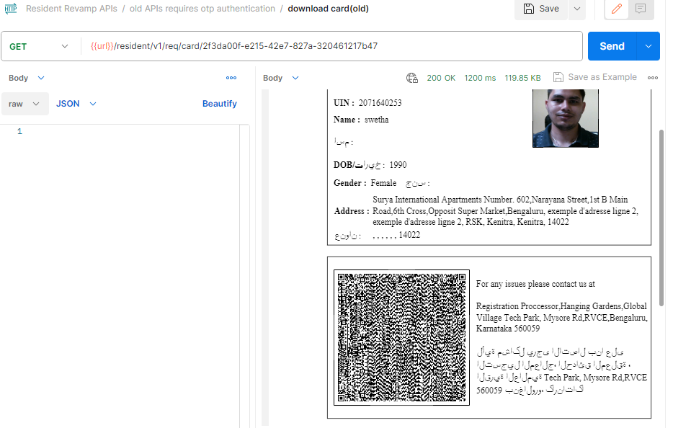

11. Login to resident service portal with OTP for unsuspended credential.

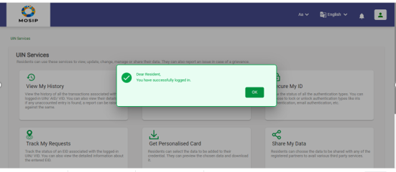

12. Login to resident service portal with biometrics for unsuspended credential

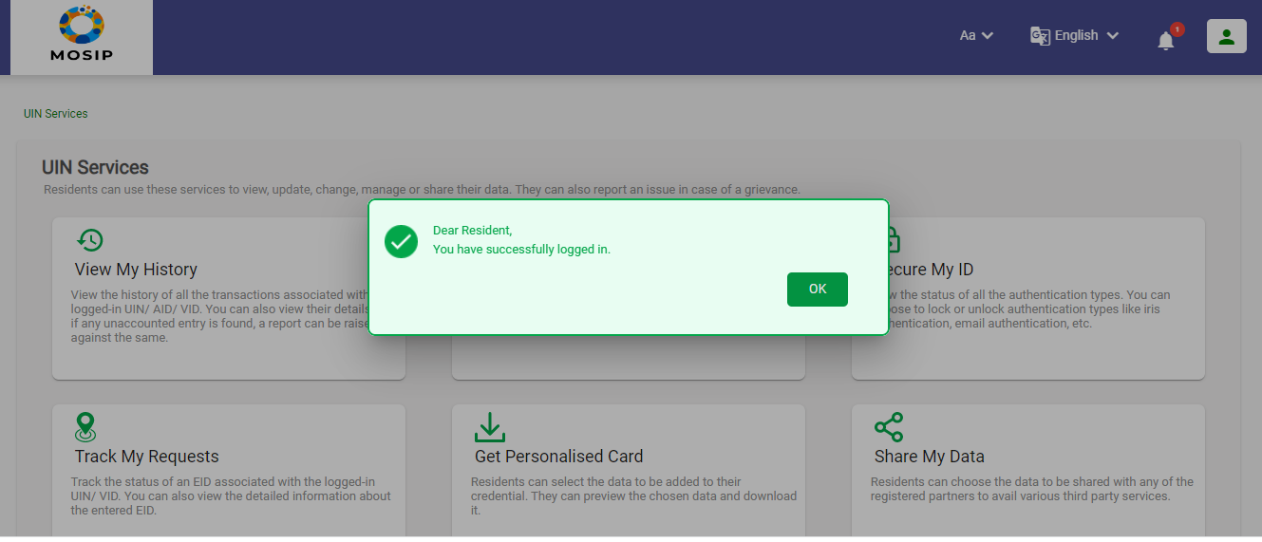

13. Credential share with unsuspended Credential

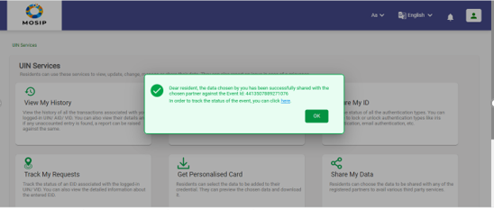

14. Login to Health service portal with unsuspended Credential.

